 | SAKR MANNING AGENCY  FOR RECRUITING EGYPTIAN LABOR ABROAD | Issue Date | 20.06.2025
 |  | Revision Date
 | Crewing Management Manual  Seafarer Employment Application | Revision | 1.1
 |  | Page | 3
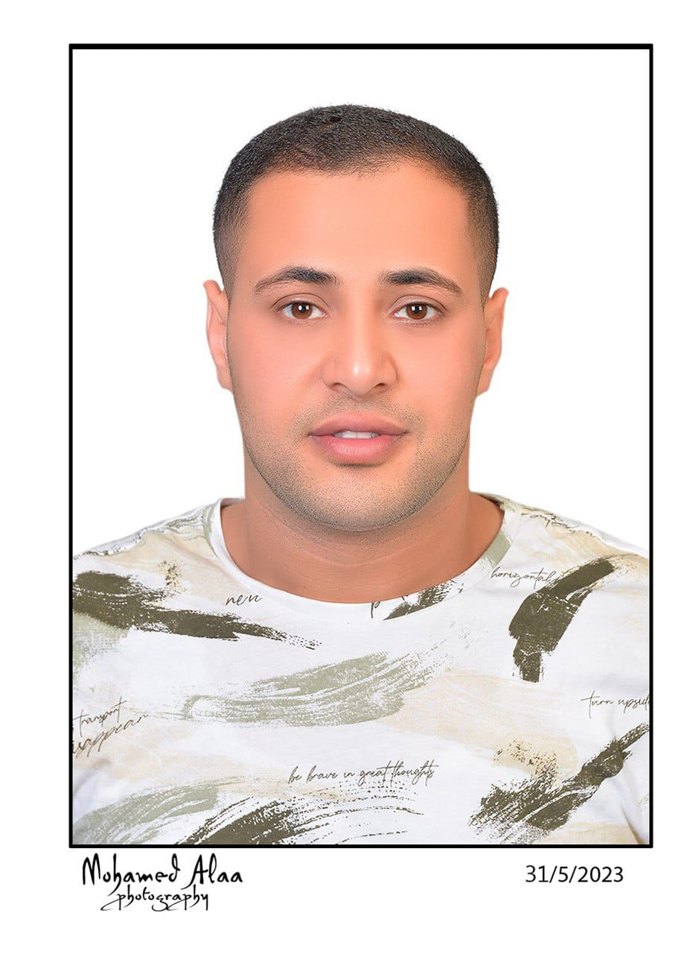
Application For Position as | ABLE SEAFARER ENGINE
Register Code. | ER-3.047
Other Position (If Any) | OILER
Register Date | 19/2/2023
Last up Date Data
Expected Salary | 1600$

1. PERSONAL DETAILS
Full Name |  | AYMAN ABDELMONEM KARIM ELSAKKA
Date Of Birth |  | 23/10/1995 |  |  |  |  |  |  | Place Of Birth |  |  |  |  |  |  |  | RASHEED
Nationality |  | EGYPT |  |  |  |  |  |  | Marital Status |  |  |  |  |  |  |  | Single |  |  |  |  |  |  |  | Married
Height (Cm) |  | 180(CM) |  |  |  |  |  |  | Overall Size |  |  |  |  |  |  |  | XL |  |  |  |  | Shirt Size |  |  |  |  |  | XL
Weight (Kg) |  | 80 |  |  |  |  |  |  | Trouser Size |  |  |  |  |  |  |  | XL |  |  |  |  | Shoes Size |  |  |  |  |  | 44
2. EDUCATION
College / School |  | Mechanical Diploma
Marline Test |  | Issued Date |  |  |  |  | Result % |  |  |  | Issued By (Authority) |  |  |  |  |  |  |  |  |  | Issued At
English Language |  | Fluent |  |  |  |  |  | Good |  |  |  |  | Average |  |  |  |  |  |  |  | Poor
ARABIC Language  ( ) |  | Fluent |  |  |  |  |  | Good |  |  |  |  | Average |  |  |  |  |  |  |  | Poor
3. CONTACT DETAILS
Home Address / City |  |  | RASHED-BEHERA – EGYPT
E-Mail |  |  | ELSKAAAYMAN@GMAIL.COM |  |  |  |  |  |  | Mobile / Tel |  |  |  |  |  | +2 01067685152 |  |  |  |  |  |  | +2 01067685152

4. TRAVEL DOCUMENTS
Type |  | Document No. |  |  |  | ISS. Date |  |  | Exp. Date |  |  |  |  | ISS. By (Authority) |  |  |  |  |  |  |  |  |  | Place of Issue
Passport |  | A32822348 |  |  |  | 25/01/2023 |  |  | 24/01/2030 |  |  |  |  | Egyptian Authority |  |  |  |  |  |  |  |  |  | BEHERA
Seaman Book |  | S00028107 |  |  |  | 16/01/2023 |  |  | 10/01/2028 |  |  |  |  | EAMS |  |  |  |  |  |  |  |  |  | Alex.
Other Seaman Book

5. PROFESSIONAL QUALIFICATION / CERTIFICATE OF COMPETENCY
Certificate Name |  |  |  |  | Number | Issue Date |  |  |  |  |  | Expiry Date |  |  |  |  |  | Issued By |  |  |  |  |  |  |  |  | Issued At
COC
GOC
D.P. INDUCTION
D.P. ADVANCED
D.P. OPERATOR (UNLIMITED)
6. NEXT OF KIN
Full Name | RASHA MOHAMED HIUSSEN ELSAKAA |  |  |  |  |  |  |  |  |  |  |  |  |  | Relationship |  |  |  |  | WIFE
Address | RASHED-BEHIRA-EGYPT
Tel. No. | 00201003838673 |  |  |  |  |  |  |  |  | Mobile |  |  | 00201003838673
7. HEALTH CERTIFICATES & VACCINATIONS
Flag State |  |  |  | Number |  |  | Issue Date |  |  |  |  | Expiry Date |  |  |  |  |  |  | Issued By |  |  |  |  |  |  | Issued At
International Medical |  |  |  | 10270 |  |  | 01/07/2024 |  |  |  |  | 30/06/2026 |  |  |  |  |  |  | EAMS |  |  |  |  |  |  | Alex.
Yellow Fever |  |  |  |  |  |  | 23/11/2021 |  |  |  |  | XXXXX |  |  |  |  |  |  | Ministry of Health
Cholera |  |  |  |  |  |  |  |  |  |  |  |  |  |  |  |  |  |  | Ministry of Health
Covid-19 |  |  |  | Vaccination Name |  |  | First Dose |  |  |  |  | Second Dose |  |  |  |  |  |  | JJANSSEN 23/10/2021
 |  |  |  | ASTRAZENQA |  |  | 15/2/2022 |  |  |  |  | 14/02/2023

8. MARINE COURSES
Course Name | Number | Issue Date | Expiry Date | Issued By / At
Personal Survival Techniques | XPST810 | 08/12/2022 | 05/12/2027 | EAMS / Alex.
Proficiency In Personal Survival Techniques | XPST810 | 08/12/2022 | 05/12/2027 | EAMS / Alex.
Fire Prevention and Fire Fighting | XNFF644 | 05/12/2022 | 03/12/2027 | EAMS / Alex.
Advanced Fire Prevention and Fire Fighting
Elementary First Aid | XNFA789 | 06/12/2022 | 03/12/2027 | EAMS / Alex.
Medical Care Studies
Personal Safety and Social Responsibilities | XNPS818 | 07/12/2022 | 05/12/2027 | EAMS / Alex.
Proficiency Of Security Awareness Training Seafarers | XNA1342 | 18/12/2022 | 06/12/2027 | EAMS / Alex.
Proficiency as a ship Security officer ( PSSO )
Proficiency In Survival Craft&Rescue Boats | 04214 | 23/01/2023 | 08/05/2024 | EAMS / Alex.
G.M.D.S.S
Communications
Advanced Communications
ECDIS Advanced Simulator (Management Level)
ECDIS Simulator (Operation Level)
Prevention and Combating of Marine Pollution
Radar & ARPA Simulator and Search &rescue
ARPA Simulator and Search
Marine Radar and automatic Radar Plotting
Bridge resource Management (B.R.M)
Engine resource Management (E.R.M)
Navigational Watch keeping
Proficiency for Rating forming part of Navigational watch (II/4)
High voltage training – operation of ship (1000 Volt and More)
Passenger Safety Cargo Safety and Hull integrity | XNXD 452 | 27/02/2023 | 22/02/2028 | EAMS / Alex.
Crowd Management Training | XNXA 474 | 26/02/2023 | 17/02/2028 | EAMS / Alex.
Crisis Management and Human Behavior Training | XNXB 476 | 26/02/2023 | 19/02/2028 | EAMS / Alex.
Safety training for Personal Prov. Direct Passengers | XNXC 488 | 27/02/2023 | 20/02/2023 | EAMS / Alex.
Practical Ability to Prepare Meals and (MLC 2006)
Personal Hygiene and Envir. Protection (MLC 2006)
Safety and Health in the Provision Meals (MLC 2006)
Food Storage and inventory Control (MLC 2006)
Ships Cook Certificate (MLC 2006)
Abel Seafarer Deck
Proficiency for Abel Seafarer Deck ( II/5 )
Engineering Watch keeping | NE200 | 09/05/2019 | 07/05/2024 | EAMS / Alex.
Proficiency for Rating forming part of a watch in engine room
Abel Seafarer Engine | 40112/22/EG | 26/12/2022 | XXXXX | EAMS / Alex.
Proficiency for Abel Seafarer Engine ( III/5 ) | 00358 | 23/01/2023 | XXXXX | EAMS / Alex.
Electro Technical Rating
Proficiency for Electro Technical rating ( III/7 )

COMPLETE SEA – SERVICE DETAILS

Name: |  |  |  |  |  |  |  | Rank: |  |  |  |  |  |  |  | Register Code:
Company Name |  |  | Rank |  | Vessel Name |  |  |  | Signed On |  |  | Signed Off |  |  |  | Period |  |  | Vessel Type |  | D.W.T. |  |  |  |  | Engine Type |  |  | BH | KW
ALBERT COMPANY NAVIERA |  |  | OILER |  | SALAH ALDEEN |  |  |  | 20/05/2018 |  |  | 28/04/2019 |  |  |  | 11Month |  |  | G.CARGO |  | 1471T |  |  |  |  | M.A.K.6 MU 453 AK H.P |  |  | 3125 | 1470
TECHNICAL MARINE INTERNATIONALS.A |  |  | OILER |  | BLUE OCEAN A |  |  |  | 05/07/2019 |  |  | 23/10/2020 |  |  |  | 13Month |  |  | LIVE STOCK |  | 4780T |  |  |  |  | MAN B&W 6L 48/60 |  |  | 6454 | 4750
MARINE EXPRESS LIVESTOCK SRL |  |  | OILER |  | M/V MIRA |  |  |  | 14/12/2020 |  |  | 06/05/2021 |  |  |  | 6Month |  |  | LIVE STOCK |  | 1464T |  |  |  |  | MAN B&W 12U28L-VO |  |  | 2963 | 1500
TECHNICAL MARINE INTERNATIONALS.A |  |  | OILER |  | BLUE OCEAN A |  |  |  | 12/08/2021 |  |  | 27/01/2022 |  |  |  | 6Month |  |  | LIVE STOCK |  | 4780T |  |  |  |  | MAN B&W 6L 48/60 |  |  | 6454 | 4750
MARINE EXPRESS LIVESTOCK SRL |  |  | OILER |  | M/V MIRA |  |  |  | 28/04/2022 |  |  | 28/11/2022 |  |  |  | 7Month |  |  | LIVE STOCK |  | 1464T |  |  |  |  | MAN B&W 12U28L-VO |  |  | 2936 | 1500
MCCL |  |  | OILER |  | SEA HELLINIS |  |  |  | 18/08/2023 |  |  | 21/05/2024 |  |  |  | 9Month |  |  | PCC |  | 14962T |  |  |  |  | MITSUBISHI-8UEC50LS |  |  | 15717 | 11560
MCCL |  |  | OILER |  | SEA HELLINIS |  |  |  | 09/08/2024 |  |  | 10/05/2025 |  |  |  | 9MONTH |  |  | PCC |  | 14962T |  |  |  |  | MITSUBISHI-8UEC50LS |  |  | 15717 | 11560
SPECIALISED EXPERIENCE
Name |  |  |  |  |  |  |  |  |  | Type |  |  |  | From |  |  | To |  |  |  |  | Comments
YACHT |  |  |  |  |  |  |  |  |  | YACHT |  |  |  | 01/01/2016 |  |  | 01/03/2018
FISHING BOATS |  |  |  |  |  |  |  |  |  | FISHING |  |  |  | 07/01/2015 |  |  | 17/12/2015
I declare that the information I have given is, to the best of my knowledge, true and complete. I also declare that the documents submitted are genuine, given and sign by persons whose names appear on them.
 |  |  |  |  |  |  |  |  |  |  |  |  | 20/06/2025 |  |  |  |  |  |  |  |  |  | AYMAN ELSKAA
 |  |  |  |  |  |  |  |  |  |  |  |  |  |  | DATE |  |  |  |  |  |  |  |  |  | SIGNATURE

